rDesk v6.0 Product Release Notes
October 27, 2009

LPS Real Estate Group is proud to announce the release of rDesk v6.0. These Product Release Notes highlight new or improved features of the product and the benefits that these features provide to LPS customers.

Release Notes contain:
- Product Enhancements – New features that you and your Website visitors can see, use, and enjoy!
- INTEGRATED Screen shots – Browser captures that illustrate many of the enhancements in this rDesk release.

Department Of Real Estate Numbers Now Available!

For all California Brokers and Agents – you can now easily include your Department of Real Estate Number (DRE #)* in CMA or Buyer’s Tour, Flyers, Neighborhood and School Reports, Action Plans and Quick Emails!
- When you enter your DRE # in Personal Profile (details below), it will automatically populate on your CMAs*, Buyers Tours*, and Neighborhood & School Reports.
- To enter your DRE # in Action Plans and Quick Email, simply scroll through the list of Tokens and select My DRE #.
- To enter your DRE # in Flyers, simply use one of the existing text boxes and enter your DRE # to display it on your Flyer.

* DRE #’s will be automatically populated in the Personal Profile except for companies using the Back Office Import (BOI). For these companies, please manually enter the DRE # for each agent or have each agent enter their DRE# in Personal Profile (shown below).

** Only base level CMA and Buyer’s Tour reports will be implemented in the 6.0 release. Custom themes will be updated after the release.

Key Benefits:
- Simple fields allow you to enter your DRE # quickly. In certain applications, your DRE # will be automatically populated!
- Saves agents valuable time while remaining compliant with new Department of Real Estate laws for agents to display the DRE # on all marketing materials

Personal Profile
To manually enter your DRE #, please use the following steps:
- Click on Personal Profile on the upper right of the screen
- Two new fields are available for your DRE #, Label and Value
- Label provides flexibility for each agent to name the DRE #. For example, enter “My DRE #” and this will appear directly in front of your number.
  - Note: This field is only available for those companies who do not have the DRE # automatically populated
- Value is where your actual DRE # is entered. Simply enter your DRE # here
- Click “Update My Personal Information”

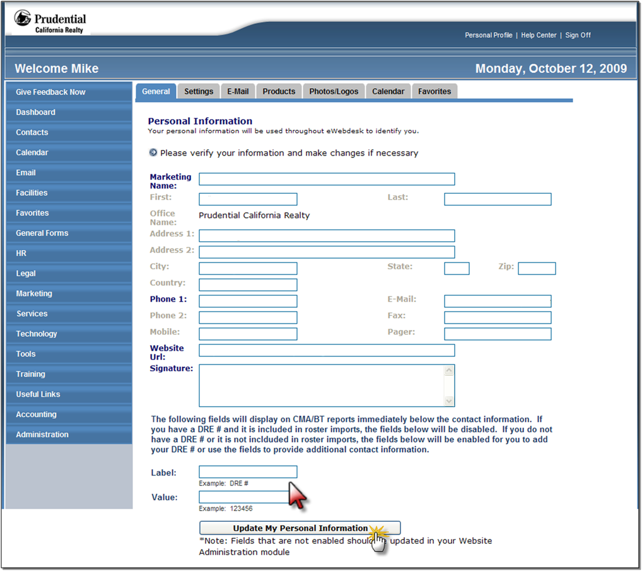

Neighborhood and School Reports display your DRE #

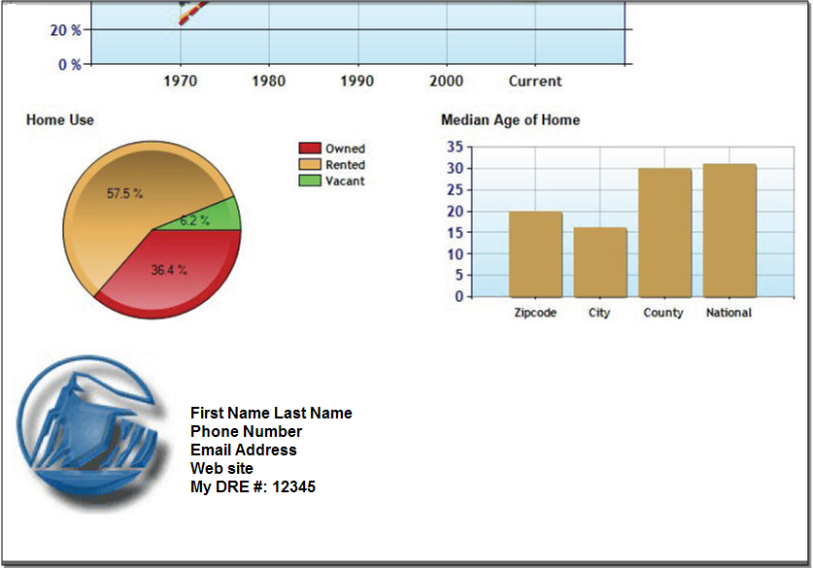

Adding Your DRE # to Quick Email and Action Plan Activities
- Simply create a new Quick Email, or Action Plan Activity
- As you type the email, place your cursor where you would like your DRE # to appear
- From the Tokens drop-down menu select “My DRE #”
- Your number (from your Personal Profile page) will automatically appear in the email
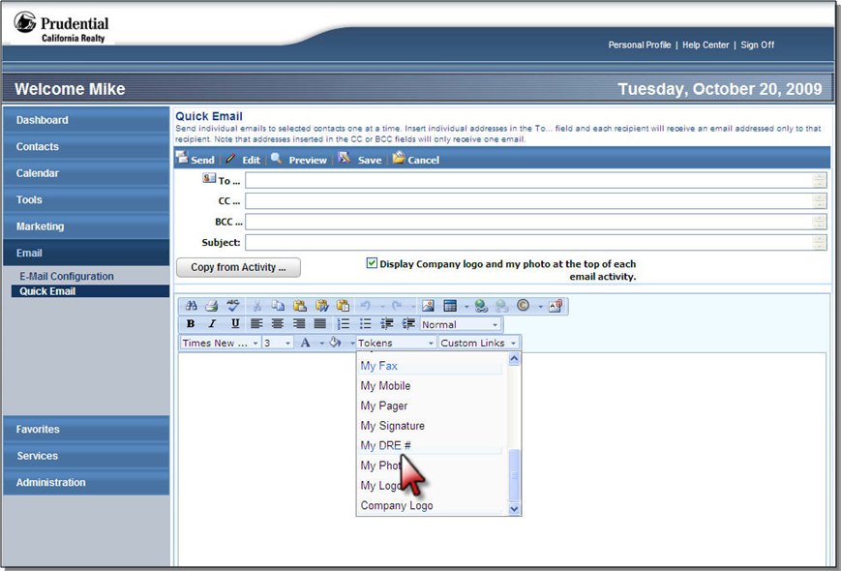
Quick Email

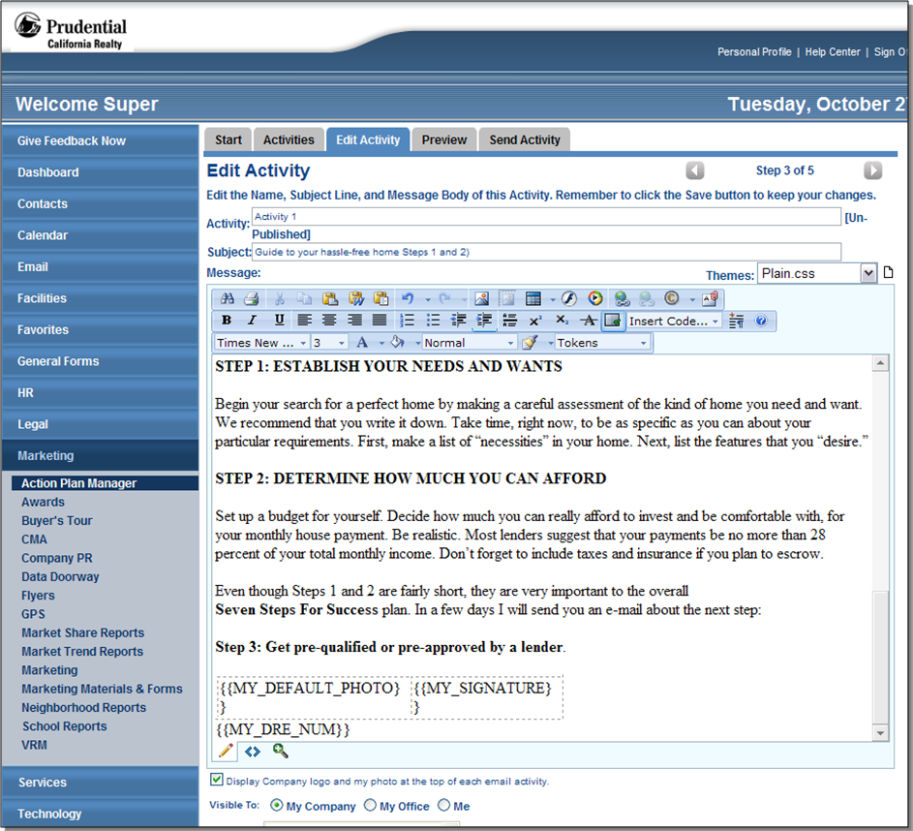
Action Plan Activities

Personal Profile Updates
Update your Marketing Name right from your Personal Profile! A Marketing Name field has been added and entered name is used in CMA and Buyers Tour. If the Marketing Name is blank, then the First Name and Last Name fields will be used. You will still be able to enter your Marketing Name manually in Flyers by using any existing text field (e.g., you may choose to enter your Marketing Name in the First Name field and leave the Last Name blank).

Note to Brokers: If you would also like to have Phone 1 and Website URL available for agents to edit, please discuss this with your account manager.
- Click on Personal Profile on the upper right of the screen
- Enter the Marketing Name you would like to use
- Click “Update My Personal Information”

Key Benefits:
- Choose how YOU want to be marketed
- Provides you with the clear marketing advantage

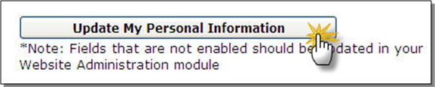

Activity Entry Page Now Matches the Action Plan Manager Entry Page

Great News! Now you have even more options in managing your Activities.
- Quickly see how many Action Plans are using each activity.
- View all Activities and edit your Activities all from the Manage Activities Screen!
- Easily copy existing Activities when you need to create similar Activities quickly
- Deleting Activities that you no longer need is easy as well. Simply check the box next to the Activity(ies)you would like to remove and click “Delete Activity(ies)”.

Key Benefits:
- Organized snapshot of all your Activities
- Links directly to View, Edit and Delete save you time, allowing you to focus more on your clients and your business

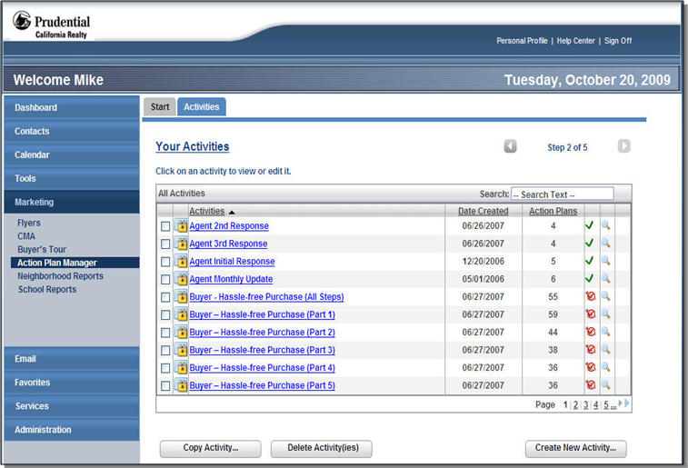

Agent Name Search on Lead Assignment Overlay

It is now easier than ever to assign leads! In the Lead Assignment overlay a new search has been added to allow for a quick agent search. Then simply select the desired agent from the list box below.

Key Benefits:
- Allows leads to be assigned faster than ever reducing the possibility of a lead going stale
- Saves valuable time for administrators who assign leads
